**Case Report**

**Fabrication of Metal Mesh Reinforced Single Maxillary Complete Denture opposing Natural Dentition**

**Ravikumar C.M1, Oza Jaimin.R2*, Vivek Sharma3** and **Shah Aijaz UL Haq4**

1Professor & Head, 2Post Graduate Student, 3Professor, 4Senior lecturer

Department of Prosthodontics and Crown & Bridge, Pacific Dental College & Research Centre, Udaipur, Rajasthan, Bharat

**Received:** 28 December 2024

**Revised:** 8 February 2025

**Accepted:** 8 March 2025

\***Corresponding Author E-mail**: [jaiminoza3448@gmail.com](mailto:jaiminoza3448@gmail.com)

**Abstract**

*It is a difficult clinical scenario and a hard therapy to prosthodontically restore a single edentulous arch that opposes natural teeth. Three factors stand out in terms of functional success when it comes to a complete denture: support, stability, and retention. The most frequent issue with. Fractures are the most common problem in single complete dentures, particularly in maxillary single complete dentures that are positioned opposite mandibular natural teeth. In order to improve the strength of a complete denture and prevent fracture of the denture, metal mesh is used to reinforce the acrylic denture. Metal mesh reinforcement increases the denture's rigidity and disperses occlusal forces without breaking and it is also good and affordable alternative for cases with single complete denture.*

**KEYWORDS**: Unimaxillary edentulous arch, Balanced occlusal, Denture fracture, Metal mesh reinforcement.

**Introduction**

Patients frequently have each jaw fully edentulous with all or some of their natural teeth in the other jaws1.Too many erupted or slanted teeth, along with the high and pointed cusps of the opposite arch natural teeth, make it difficult for dentists to fabricate a single full denture1,2.Unfavourable occlusal relationships arise, which can cause discomfort, mucosal changes, and ultimately ridge resorption by pushing the maxillary denture out of position. The mandibular anterior teeth's fixed position makes the arrangement of the upper teeth more difficult, leading to problems with phonetics, function, and appearance3.It also leads to excessive mechanical forces on the denture.

The most popular material for making denture foundations is heat-cured denture base, which is affordable and suitable in terms of appearance, biology, and physical attributes2.However, the acrylic resin has the disadvantages of poor strength, which include low impact strength and low fatigue resistance4.As a result, there lies chances of denture fracture when used in single complete denture2.To avoid complete denture fracture, advancements in material and techniques are essential. such as the use of carbon fiber, E-glass fiber reinforced PMMA, acrylic resin bases reinforced with wire netting, and metal reinforced denture bases. Among these techniques, metal mesh reinforcement is the most cost-effective and time-efficient way to greatly improve denture strength5.

The manufacture of a single maxillary complete denture reinforced with commercially available prefabricated metal mesh is the subject of this case study.

**Case report**

A 62-year-old male patient presented to the department of prosthodontics crown and bridge, Pacific Dental College and Research Centre, Udaipur, for fabrication of a new complete denture due to ill-fitting of the denture. The patient has been wearing dentures for the past eight years.

There was no relevant medical history found. Upon intraoral examination, a fibrous growth measuring approximately 1.5 cm × 0.5 cm was found in the right labial vestibule. which was polypoid and has a soft and smooth texture [Figure 1]. Completely edentulous maxillary arch and Kennedy's class III partially edentulous mandibular arch [Figures 7 & 8].

The patient was advised to remove the tissue growth as part of the treatment plan, and then they were given the choice between an implant-supported maxillary complete denture and a traditional single maxillary complete denture. The patient is unwilling to accept an implant-supported denture as a backup option because of surgical and financial limitations. As the initial treatment option, the patient opted for a single maxillary denture with metal mesh reinforcement in the acrylic denture base and a removable partial denture in the mandibular arch.

**Procedure**

For the removal of the denture epulis patient was referred to the department of periodontology. The entire treatment plan was described to the patient, and consent was obtained. The patient was told not to wear the old denture, and he was encouraged and educated to maintain good oral hygiene.

Ten days later, the patient was called back, and oral prophylaxis was administered. The lesion was removed using a diode laser. Postoperative instructions were provided, and the specimen was collected and sent for histopathological examination, which revealed a benign lesion with fibrous connective tissue.

After 7 days, the patient was examined again, and the healing process was found to be satisfactory [Figure 2]. Following that, the patient was referred to our department for denture fabrication.

* Using impression compound, the maxillary arch's primary impression was made and alginate impression material was used for the mandibular partially edentulous archon the first visit. The primary cast was made [Figure 5].
* A wax spacer was adapted and custom tray was fabricated on the maxillary primary cast using auto-polymerizing acrylic resin [Figure 6].
* During the second visit, green stick compound was use for border mold and zinc oxide eugenol paste for the final impression.
* The maxillary and mandibular denture bases were made with auto-polymerizing acrylic resin, while the occlusal rim was made with modelling wax.
* During the third visit, the maxillo-mandibular jaw relation was recoded and the master cast was mounted on a mean value articulator based on the records [Figure 7].
* A transparent vacuum-formed template was created over the mandible cast using the Bruce process [Figure 8].
* Maxillary teeth were arranged based on the contour of the occlusal rim and glass plate relation [Figure 9].
* Grind of denture teeth and natural stone teeth on the cast was done and the occlusal was adjusted. The modified cusps are marked, and the template is re-seated [Figure 10].
* In the prepared region, voids are discernible. The preparation area becomes open when the template is inserted into the patient's mouth [Figure 11].
* During the fourth visit, natural teeth are reduced as a guide, followed by a trial denture to ensure fit, function, and aesthetics [Figure 12].
* The maxillary temporary denture base with teeth arrangement was invested and dewaxed before packing. A metal mesh was adapted to the cast in the maxillary mold. The denture was packed with heat-cured denture base material and cured as usual [Figure 13].
* Following bench cooling, deflasking, finishing, and polishing were completed [Figure 14].
* On the fifth visit, denture insertion was performed [Figures 15,16 & 17], and the patient was given post-operative instructions. The patient was later called for a follow-up adjustment.
* The patient was pleased with the functional and aesthetic qualities of the denture at the follow-up appointment [Figure 18].

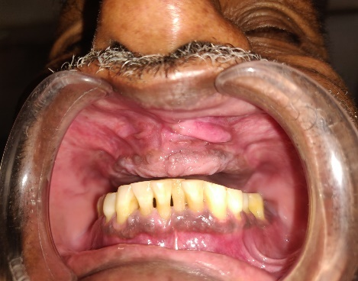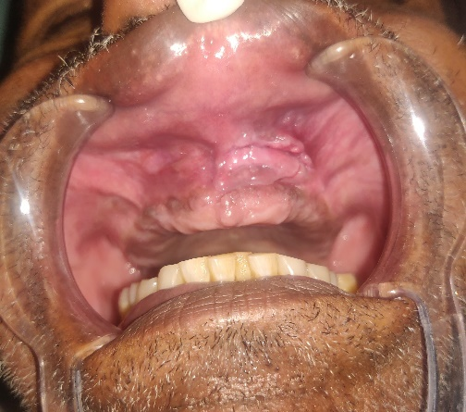

**Figure 1**: Epulis fissurstum seen in Upper Anterolateral Region

**Figure 2**: Post-operative Follow-up after 7 Days

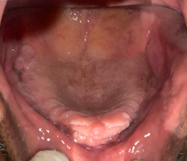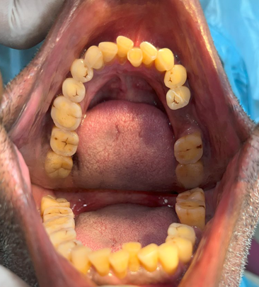

**Figure 4**: Kennedy’s Class III Partially Edentulous Mandibular arch

**Figure 3**: Completely Edentulous Maxillary Arch

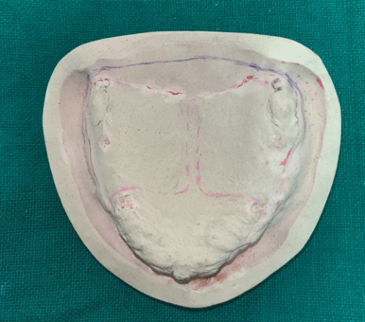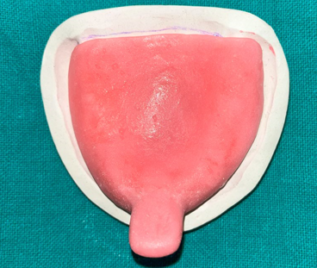

**Figure 6**: Maxillary Special Tray

**Figure 5**: Maxillary Primary Cast

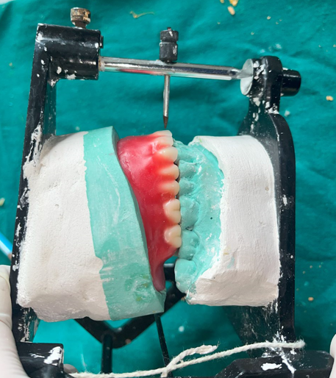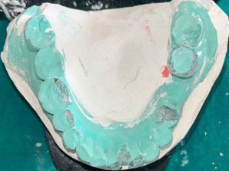

**Figure 8**: Interferences Marked on Cast

**Figure 7**: Mounted Cast on Articulator

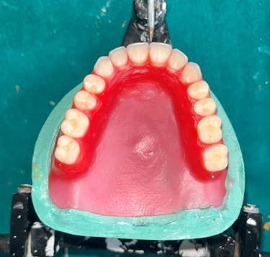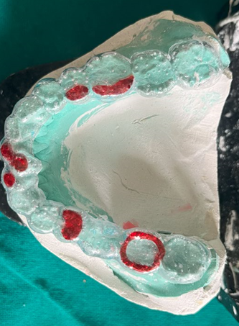

**Figure 10**: Mandibular Cast with Vacuum Formed Sheet and Interferences Marked on Vacuum Formed Sheet

**Figure 9**: Maxillary Teeth Arrangement Done

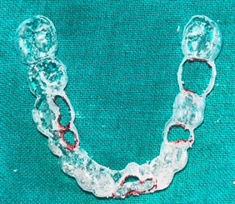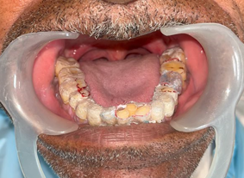

**Figure 12**: Interferences Removed using Vacuum Sheet

**Figure 11**: Perforation Created on Vacuum Sheet for Occlusal Correction

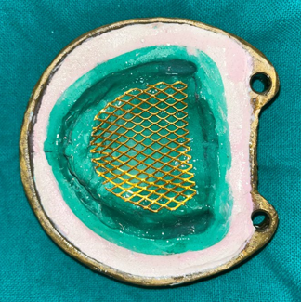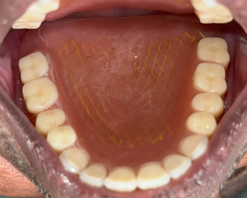

**Figure 13**: Adaptation of Metal Mesh on Maxillary Master Cast

**Figure 14**: Metal Mesh Incorporated in Maxillary Denture

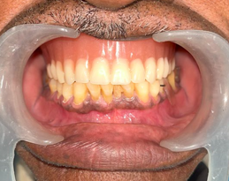

**Figure 15**: Occlusion in Centric Position

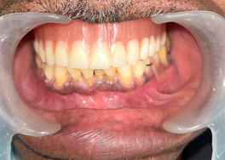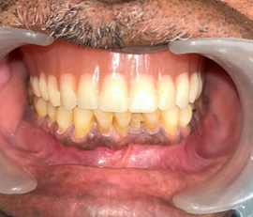

**Figure 16**: Right Lateral View **Figure 17**: Left Lateral View

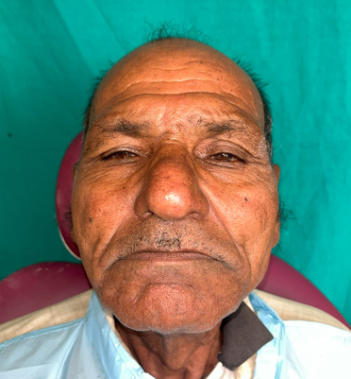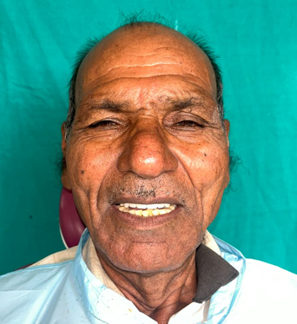

**Figure 18**: Pre-treatment and Post-treatment Profile

**Discussion**

Fibrous hyperplasia induced by dentures (DIFH) is a condition characterized by excessive growth of fibrous connective tissue in the oral mucosa, typically resulting from trauma. This trauma often occurs due to poorly fitting denture borders, leading to chronic, low-intensity injury. Other contributing factors may include parafunctional habits, inadequate oral hygiene, and smoking6.

Clinically, DIFH manifests as painless, raised, smooth, pinkish folds of hyperplastic mucosa, typically found in the gingivolabial or gingivobuccal sulci, particularly in the anterior region of the mouth. The size depends on the severity of the trauma7.

DIFH can be treated conservatively or surgically. Diode laser surgery has several advantages over traditional scalpel surgery, including improved incision performance, effective coagulation, reduced postoperative pain and swelling, and less scarring6.

Following surgical excision, it is critical to make a new denture for the patient and educate them on proper oral hygiene habits6.

1. When a complete denture is opposed by natural teeth, it will require some degree of contouring to provide a harmonious occlusal. The reason for such alteration is mainly due to unfavourable inclination of the occlusal plane;
2. Misplaced individual teeth that have assumed position resulting in excessively steep cuspal inclination and
3. To widen buccolingual width of the natural teeth.[1]

Several techniques for modifying the existing occlusal pattern before denture construction have been proposed3:

1. Swenson’s technique
2. Yurkstas method
3. Bruce method
4. Boucher method
5. L. Klirk Gardner’s technique
6. Han Kuang Tan’s technique
7. The use of Boadrick’s Flag

Bruce developed a method for reshaping natural teeth using a transparent resin template to achieve an acceptable occlusion while fabricating complete dentures that oppose natural dentition2.

Impact and flexural fatigue are the two types of forces that cause denture fracture. Impact fractures are caused by a sudden blow to the denture or the accidental dropping of the denture from the hands or mouth. Flexural fatigue occurs when lower dimension stress is applied repeatedly, resulting in the formation of microcracks in the denture base5.

PMMA resin is widely used in prosthetic dentistry for the fabrication of denture bases. It has many advantages, but it also has some drawbacks, such as poor inherent strength characteristics such as low impact strength and fatigue resistance. There is around a 2:1 ratio of maxillary to mandibular denture fractures. Poor fit and an unbalanced occlusion are the most frequent causes of fractures4.

Therefore, many attempts have been made to enhance the strength properties of acrylic denture bases like4:

* Attempts to modify the chemical structure with cross-linking agents like polyethylene glycol di-methacrylate orcopolymerization with rubber failed to significantly increase material strength.
* Polycarbonates and polyamides are not commonly used as substitutes for PMMA due to their high cost and technique sensitivity.
* Incorporation of fibers or metal inserts into denture bases.

Several methods have been used to reinforce acrylic resin denture bases. Metal inserts have been used in the form of wires, meshes, and plates, with different fibers such as carbon, aramid, glass, and polyethylene. Carbon and aramid fibers are avoided due to their undesirable colour and toxicity. Glass and polyethylene fibres are successfully used as reinforcement due to their stiffness, strength, biocompatibility, white translucent appearance, and low water absorption4.

PMMA's resistance to fracture is enhanced with metal strengtheners. The use of a metal base and metal mesh reinforcement strengthens the denture while also reducing the spread of microcracks. Stainless steel and gold-plated metal mesh are both commercially available. Metal mesh does not add weight to the denture and reduces the risk of fracture5.

There are some disadvantages to using metal mesh. It looks unattractive if it appears on the labial portion of the denture when the patient smiles. It is prone to corrosion and adheres poorly to acrylic denture bases. In some cases, the patient may occasionally be allergic to metal5.

In order to completely satisfy the needs of patients and clinicians, advancements in materials and processes are necessary. Implant-supported overdentures are a newer treatment option for single dentures. Not every patient can afford implant therapy because of financial limitations. Metal mesh reinforcement is an affordable and promising solution in such cases5.

So, in this case, gold-plated metal mesh is used to reinforce the maxillary denture.

**Conclusion**

Complete unimaxillary removable prosthesis is a complex treatment that must be perfectly reasoned to ensure prosthetic durability. It also presents a challenge for prosthodontists to provide successful treatment for patients who have one completely edentulous arch and natural teeth in another arch. Metal mesh reinforcement for conventional complete dentures can provide numerous advantages over commonly used acrylic dentures, including increased strength and fracture resistance. They even reduce the number of post-insertion visits for patients, and patient satisfaction improves when it is used. This is a viable treatment option for all patients who experience repeated denture fractures due to heavy occlusal loading.

**CONFLICT OF INTEREST**: None

**FINANCIAL SUPPORT**: None

**REFERENCES**

1. Kaira LS, Richa and Singh R Single Complete Denture in Mandibular Arch Opposing Natural Dentition – A Case Report. NUJHS 2013; 3:1 ISSN 2249-7110.
2. Bhandari A, Thakur SN, Khanal B Maxillary Single Complete Denture with Metal Mesh Reinforcement: A Case Report. JNPS 2022;5(2):78-83.
3. Vikhe D.M, Gangadhar S.A, Single Complete Denture a Corrective Prosthodontics: A Clinical Report. Pravara Med Ren 2014; 6(1):17-19.
4. Mallikarjuna Murthy H B, Sharaz Shaik. Effect of Reinforcement Using Stainless Steel Mesh, Glass Fibers, and Polyethylene on the

Impact Strength of Heat Cure Denture Base Resin - An In vitro Study. J Int Oral Health2015; 7(6):71-79.

1. Agrawal P, Arunachalam S, Saha A, Fabrication of Metal Mesh Reinforced Single Maxillary Denture. JPID 2021;5(1):21-25.
2. Er-Raji Samir et al. Diode laser surgery for the treatment of denture-induced fibrous hyperplasia: a case report. Pan African Medical Journal. 2024;47(105). ISSN: 1937-8688
3. Mozzati M, Mortellaro C, Gallesio G, Ruggiero T, Pol R. Surgical treatment of denture-induced fibrous hyperplasia with plasma rich in growth factors. J Craniofac Surg. 2015 May;26(3): 772.
4. Bounaouara, R., Tayari, O., Mansour, L., & Jaouadi, J. Single Maxillary Complete Denture: Particularities and Treatment Considerations. EJDENT, 2023;*4*(1), 1–7.