**Case Report**

**Prosthodontic Rehabilitation of Severely Decayed Posterior Teeth using Custom Made Post & Core by Direct Technique**

**Ravikumar C.M.1, Dadhaniya Salvi2*, Vivek Sharma3 and Shah Aijaz Ulhaq4**

1Professor & HOD, 2Post Graduate Student, 3Professor, 4Seniour Lecturer

Department of Prosthodontics and Crown & Bridge, Pacific Dental College and Research Centre, Udaipur, Rajasthan, Bharat

**Received**: 27 December 2024

**Revised**: 8 February 2025

**Accepted**: 8 March 2025

\***Corresponding Author E-mail**: [salvi.dadhaniya@gmail.com](mailto:salvi.dadhaniya@gmail.com)

**Abstract**

*The successful outcome of the treatment of severely damaged tooth structure depends on good endodontic treatment followed by prosthodontic treatment. Excessive loss of dental hard tissues impairs the cosmetic quality of future prosthetic restorations. The purpose of prosthodontic and restorative dentistry is to repair missing tooth structure, preserve function and aesthetics, and prevent against fractures and infections. Endodontically treated teeth need extra care since they are brittle, and the remaining coronal tooth structure is usually insufficient to support complete crowns. To give foundation rehabilitation, posts and cores are utilised. For a long time, a cast metal post and core served as the foundation restoration for a prosthetic crown. When a significant percentage of tooth structure is lost or there is enough ferrule, a custom cast post and core is recommended.*

**KEYWORDS**: Endodontic treatment, Prosthetic restorations, Replace missing tooth structure, Function and aesthetics, Cast metal post, Ferrule

**Introduction**

Previously, teeth removal was the most usual treatment method for severely decaying teeth, but today’s dental therapy focuses on a more conservative approach1.

Endodontically treated posterior teeth are frequently damaged due to caries and access requirements, sometimes to the point where all of the coronal structure’s walls are eliminated and only the radicular section remains2.It is thought that if tooth structure is lost due to caries, trauma, or both, endodontically treated teeth are more likely to fracture3.The purpose of prosthodontic and restorative dentistry is to repair missing tooth structure, preserve function and aesthetics, and prevent against fractures and infections1.

There are numerous post-endodontic rehabilitation methods and resources accessible today for the cases where there is very little remaining coronal tooth structure4.The objective of the post and core is primarily to replace missing coronal tooth structure sufficiently to provide adequate retention & resistance for the crown that will eventually restore the function and the aesthetics of the tooth5.

Custom cast posts and cores are ideal for canals with an extremely tapered, noncircular cross section, irregularly shaped canals, and roots that have little to no coronal tooth structure left7.Although many approaches for fabricating the cast post and core have been documented, they can be classified into two types based on whether the pattern is generated intraorally (direct technique) or extra-orally (indirect technique) on a functioning cast6.

Direct fabrication of the post and core design is preferable because it allows for more accurate casting of post preparation in less laboratory time. This technique is most suited for lengthy, thin post preparations in addition to short preparations requiring exact fit to ensure retention8.The chance of perforation of the root and patient trauma is reduced, and the surgery is quite inexpensive. The mandibular second molar was restored in this case study utilising a custom-made post and core, followed by a full metal restoration using the direct approach.

**Case Report**

A 25-year-old female patient reported to the Department of Prosthodontics, Crown and Bridge, Pacific Dental College and Research Centre, Udaipur, with the chief complaint of pain and difficulty in chewing. The extraoral examination revealed no significant findings. An intraoral examination showed grossly caries 37. The tooth was tender on percussion. On radiographic examination, radiolucency was observed from the coronal portion of the tooth involving the pulp. Radiolucency was also observed at the distal root end. A two-phase comprehensive treatment plan was created: an endodontic phase and a restorative phase.

**Endodontic Phase**

Caries was excavated, and unsupported dental structures were removed. The access cavity was improved, and a working length was obtained. The biomechanical preparation was accomplished. During preparation, canals were irrigated with normal saline. Triple antibiotic paste was inserted in the canal, and the patient was recalled after two weeks.

At the 2nd appointment, the patient was asymptomatic, and obturation was done, and post-endo restoration was done using temporary restorative material.

**Restorative Phase**

On examination after post-endo treatment, the remaining tooth structure found was very little hence, a custom-made post and core was planned.

* In both distal and mesial root canals, gutta-percha was removed, and the canal was prepared using No. 1 to No. 4 piezo reamers. In the distal root canal, 4-5 mm of gutta-percha was left behind for an apical seal, and in the mesial root canal, gutta-percha was removed and prepared to the curvature of the root. To prevent apical leaking, chemical solvents were avoided when removing gutta-percha [Figures 1 & 2].

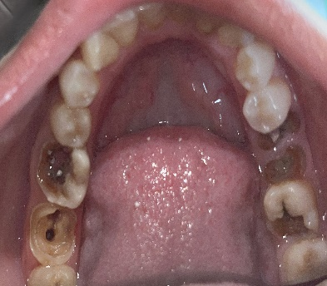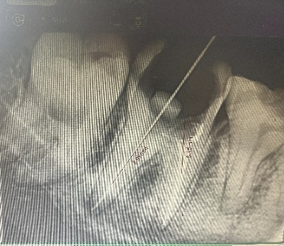

**Figure 1 Figure 2**

* The tooth was done, and the ferrule was prepared. Loose-fitting 0.7mm diameter stainless steel orthodontic wire was tired into the prepared post space.
* The canal was lubricated with petroleum jelly before taking impression of the canal.
* Mesial and distal prepared root canal impression was made using pattern resin. Once the canal impression was completed, additional material was applied to fabricate the core. The position of the future prosthetic teeth was taken into consideration when shaping the core component of the crown [Figure 3].

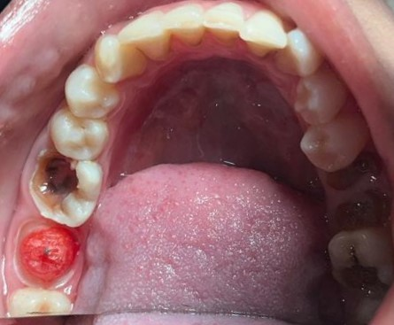

**Figure 3**

* The post and core pattern were sprued, invested, and then cast. The retrieved casting was placed in the patient’s mouth, and the final finish was achieved intraorally [Figure 4].

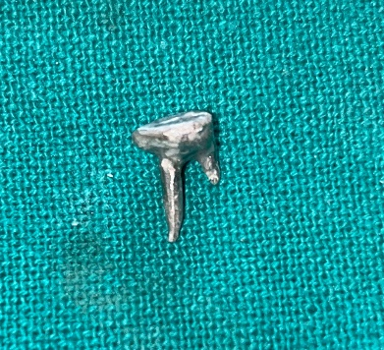

**Figure 4**

* Using the luting cement, the custom-made post was luted in the prepared canal [Figure 5].

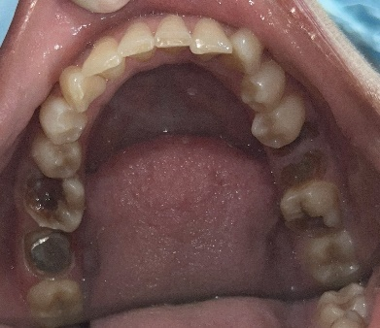

**Figure 5**

* The final impression was made using the putty relining technique.
* The all-metal crown was fabricated and cemented in the next appointment.
* Patient is recalled after 7 days for follow-up, and the treatment outcome was fulfilled according to the patient’s functional expectation.

**Discussion**

Endodontically treated teeth cannot provide adequate support and retention for restoration, hence they are often repaired using a post and core3.An ideal post system should have the following features1:

* Physical properties similar to dentin
* Maximum retention with little removal of dentin
* Distribution of functional stresses evenly along the root surface
* Aesthetic compatibility with the definitive restoration and surrounding tissue
* Minimal stress during placement and cementation
* Resistance to displacement
* Good core retention
* Easy retrievability
* Material compatibility with core
* Ease of use, safety and reliability, and
* Reasonable cost.

As a result, the physician must be knowledgeable in selecting the appropriate type of post and core systems to achieve the biological, mechanical, and aesthetic requirements of each individual tooth.

A post-and-core restoration is implanted in a badly broken-down tooth to restore the bulk of the coronal region of the tooth, making it easier to restore the tooth later with an indirect extra-coronal restoration5.

There are numerous procedures for creating posts and cores for fragmented and endodontically treated teeth. They include both custom-made and prefabricated posts7.

Endodontically treated teeth’s resistance to fracture has been shown to be primarily determined by the quantity of surviving tooth structure and adhesive surface, adhesion quality, and post type3.

Pre-fabricated posts are increasingly popular in comparison to custom-cast posts and cores. However, cast posts and cores offer their own set of advantages, including the preservation of maximum tooth structure because the post is designed to match the radicular space with improved adaptability to the root canal5.Cast posts might be used to slightly alter the core angulation3.The post does not have to keep the core as it is an essential component of the post. Another benefit is the anti-rotational characteristic5.Custom cast post construction is taken into consideration for the best retention and resistance while restoring the tooth’s functionality4.

However, it has the disadvantage of requiring numerous visit procedures. One disadvantage is the use of corrosive dissimilar metals for the post and core. Many researchers found that there is a link between root fracture and corrosion of base metal prefabricated post and cast core solutions for restoring them. Another disadvantage of casting a core onto a prefabricated post system is that the casting process may negatively impact the physical qualities of wrought metal posts7.

A ferrule is a circumferential ring of tooth structure surrounded by the cervical section of the crown. It has a bracing action that improves the stability of root canal treated teeth. It enables the crown and root to operate as one unit and physiologically conveys occlusal stresses to the periodontal tissues3.

Preparation of dowel space within 3-5mm of the apical seal is no longer considered because a post length equal to the predicted crown length is considered acceptable. When two posts are placed in divergent roots, this length is unnecessary; much shorter posts can provide adequate retention2,10.A single cast post and core in the largest and straightest canal of a multirooted tooth was also disregarded since a single post in the outermost canal could cause the core to rotate or provide insufficient retention. Additionally, a long post raises the possibility of a root perforation, which could result in failure2.

**Conclusion**

With so many materials and post designs available for the restoration of endodontically treated teeth, the clinician must be careful in selecting the post system that best meets the unique needs of each tooth. A full grasp of posts is required to make the appropriate decision, as there are numerous options accessible, such as custom-made posts and prefabricated posts. The benefits of using a cast post and core include a bespoke fit to root configuration, little change of canal anatomy, and adaptation to big, irregularly shaped canals and orifices. It is also used to replace severe loss of coronal tooth structure with limited ferrule. Finally, the choice of core material and final restoration are critical for long-term clinical success.

**CONFLICT OF INTEREST**: None

**FINANCIAL SUPPORT**: None

**REFERENCES**

1. Kalra H, Sukhija U, Rassawet RR. A Review on Post and Core. Sch J Dent Sci, March, 2020; 7(3): 51-56.
2. Bansal R, Mehrotra N, Chowdhary P. Management of Grossly Decayed Mandibular Molar with Different Designs of Split Cast Post and Core. Case Rep Dent. 2016; 2016:2976941.
3. Iqbal N, Farooq S. Rehabilitation of endodontically treated tooth with cast post and core: A case study. IJADS 2020; 6(3): 84-86.
4. Umre U, Sedani S, Nikhade P. A Case Report on the Rehabilitation of Severely Worn Teeth Using a Custom-Made Cast Post. Cureus 14(10): e30528.
5. Uniyal S, Aeran H, Kwatra B. Post & Core: An Easy and Effective Treatment Modality for Severely Damaged Teeth. Int J Oral Health Dent, 2015;1(2):99-104.
6. B. E. Kanoy, C. F. Brantley. Indirect post and core fabrication die-investment stone. J Prosthet Dent,1985;[54(6](https://www.sciencedirect.com/journal/the-journal-of-prosthetic-dentistry/vol/54/issue/6)):757-759.
7. Hameed NASA. Multi-piece post-crown for multi-rooted teeth with non-parallel canals: a direct pattern technique. J Dent Health Oral Disord Ther. 2014;1(4):130‒133.
8. J.R. Gavelis, D.M. Hope. A modified indirect cast post and core technique. J Prosthet Dent,1984;[51(1)](https://www.sciencedirect.com/journal/the-journal-of-prosthetic-dentistry/vol/51/issue/1):55-59.

1. [Steven M. Morgano](https://www.sciencedirect.com/author/7003332246/steven-m-morgano) , Patrice Milot. Clinical success of cast metal posts and cores. J Prosthet Dent,1993;70(1):11-16.
2. Aquaviva S. Fernandes, Sharat Shetty, and Ivy Coutinho, J Prosthet Dent 2003;90:556-62.